Introducing the Business Analysis Process

Many aspiring and current Business Analysts have told us they are confused about the responsibilities of the BA at various points within a project.

To help, we've created The BA Guide's Business Analysis Process. This diagram (and details below it) explain at a high level what the BA is responsible for.  
  
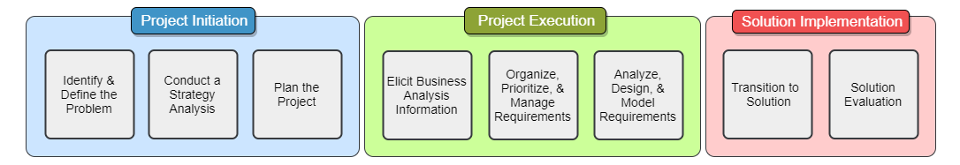

**PROJECT INITIATION**

* **Identifying the problem** – Determining a business pain point, finding its root cause, and selling the value of fixing it
* **Conducting a strategy analysis** – Defining what the solution could function like and perform a gap analysis on how to go from the current ‘as-is’ state to the future ‘to-be’ state
* **Planning the project** – Assisting the Project Manager to put together the project details (project charter, stakeholder analysis, etc.)

**PROJECT EXECUTION**

* **Eliciting business analysis information** – Uncovering and documenting the full needs of the organization to make sure they are accounted for in the solution
* **Organizing, prioritizing, and managing the requirements** – Keeping up with ever-changing organizational needs and wants as the project unfolds and making sure the most crucial requirements are completed early on
* **Analyzing, designing, and modeling requirements** – Taking the communicated requirements and formulating how they can be accomplished within the solution

**SOLUTION IMPLEMENTATION**

* **Transitioning to the solution** – Determine the necessary steps and help to implement and move to the new solution
* **Solution evaluation** – Conduct a post-project review to validate the solution meets the business needs, document any further needs, and understand any lessons learned from the project